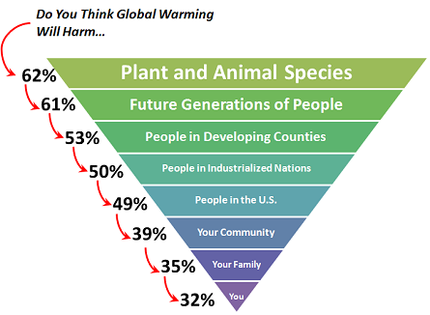

from: http://www.climatechangecommunication.org/images/files/Climate_Change_in_the_American_Mind.pdf

